**DOCUMENTATION TECHNIQUE**

Serveur :

● Apache

● Version PHP 8.1

● MariaDB

● XAMPP

Pour le front :

● HTML 5

● CSS

● SCSS

● Bootstrap

● JavaScript

● JQuery

Pour le back :

● Symfony, Composer

● MySQL

Bundles:

● Doctrine

● Twig

● Webpack encore

● Maker

● EasyAdmin

● Fixture

● Security

● Vich Uploader

**DIAGRAMME UML**

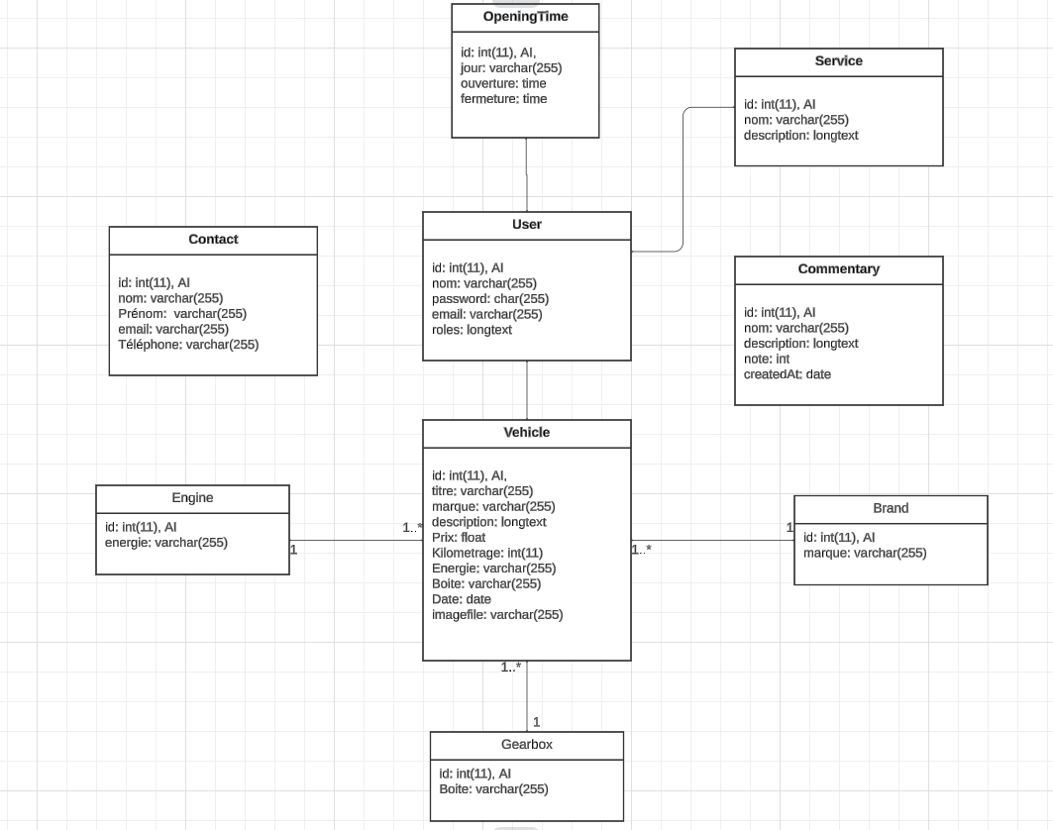

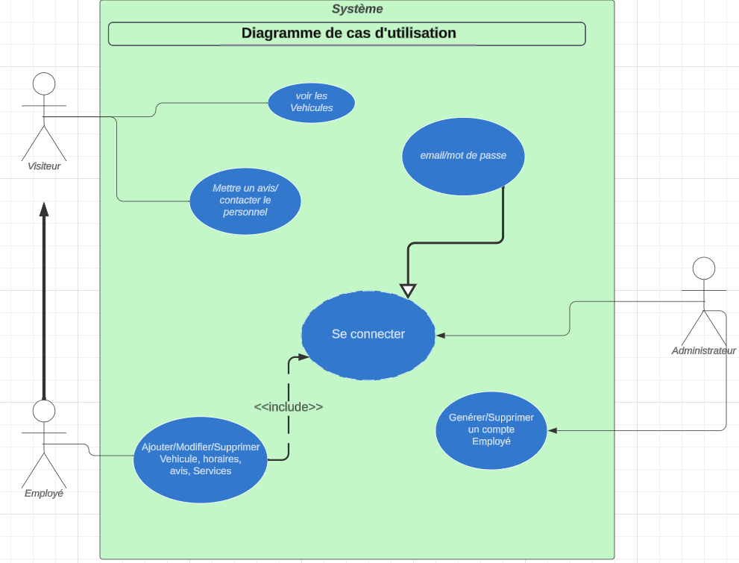

DIAGRAMMES DE SEQUENCES

